Vishwakarma Institute of Technology
Department of Computer Engineering
A.Y. 2025-26 (Sem I)
Course: Design and Analysis of Algorithms
Tutorial 2: Problem Solving

- Suppose you are given a stack of n pancakes of different sizes. You want to sort the pancakes so that smaller pancakes are on top of larger pancakes. The only operation you can perform is flip(k) for any integer k between 1 and n. The operation flip(k) involves inserting a spatula under the k th pancake from top and flip the pile of top k pancakes. For example, the p
Picture below shows flip(3) operation.
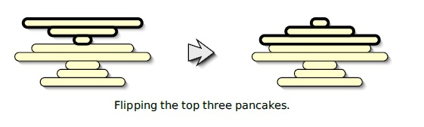
Describe an algorithm to sort an arbitrary stack of n pancakes using as few flips as possible. Exactly how many flips does your algorithm perform in the worst case?

- We have a directed path with n nodes. The nodes are numbered from 1 to n. We are initially at the first node. We can go to other nodes by one of the following moves:
Step: Go from node i to node i+1.
Jump: Roll an n-sided fair die. Move to the node that shows up on the face of the die.
In other words, step takes us to the next node and jump takes us to a node from {1, 2, …, n} chosen uniformly at random. Each move takes one second to execute. At each second, we need to pick one of the two types of moves to execute.
Our goal is to reach the nth node as quickly as possible. Describe a strategy that minimizes the expected time to reach the goal. What is the expected time taken by your strategy?

